Deliverable 2 – Technical Report

2012 UAV Outback Challenge – Search and Rescue Challenge

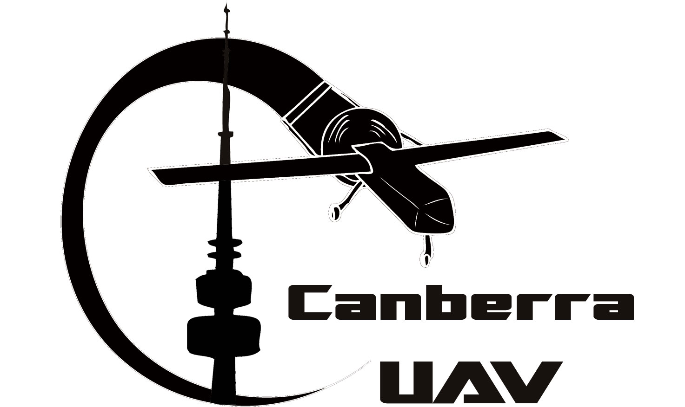

[www.canberrauav.com](http://www.canberrauav.com)

Proudly Sponsored by:

Paul Tridgell



Terry Porter

Grant Morphett

# Table of Contents

1 Table of Contents 2

2 Statement of Originality and Accuracy 3

3 Executive Summary 4

4 Introduction 5

5 Design Approach and Rationale 6

5.1 Rationale 6

5.2 Airframe 6

5.3 Imaging System 7

5.4 Autopilots 7

5.5 Radio Links 7

5.6 Control and Termination System 7

5.7 Ground Control Station 7

6 Risk Management Approach 8

6.1 Spectrum Management 8

6.2 Flight Termination (OBC 5.5.1) 8

6.3 Loss of data link (OBC 5.5.2) 9

6.4 Engine Failure (OBC 5.5.3) 9

6.5 Loss of GPS position (OBC 5.5.4) 9

6.6 Geo-fencing (OBC 5.5.5) 9

6.7 Autopilot lock-up (OBC 5.5.6) 9

6.8 Failure of Ground Control Station (OBC 5.5.7) 10

6.9 Battery management 10

6.10 Failure of Stability Augmentation System (OBC 5.5.8) 10

6.11 Ground Tests and Checklists 10

6.12 Testing 10

6.13 Personnel Safety Procedures 11

6.14 Overall Risk assessment 11

7 Flight Test Results and Discussion 13

7.1 Project Status 13

7.2 Results 13

7.3 Conclusions 15

8 Compliance Statement 16

# Statement of Originality and Accuracy

*We declare that this report is entirely the work of the team members listed below, and has not previously been submitted by us, or others for this challenge or any other similar event.*

*We have acknowledged external material with appropriate references, quotes or notes to indicate its source.*

*We declare that this report is an accurate record of activities carried out by us in preparing for this specific challenge. The events, data and other material contained within this report actually occurred and have been fully detailed.*

Stephen Dade (team manager)

Darrell Burkey

Michael Fagan

Chris Gough

Andrew Moss

Jack Pittar

Matthew Ridley

Jason Stokes

Andrew Tridgell

Brett White

# Executive Summary

CanberraUAV has been fortunate to attract team members from a wide variety of relevant disciplines, including aeromodelling, mechatronics, software engineering and communications engineering. This has allowed us to push the boundaries on our entry; especially given this is our first attempt at the Outback UAV Challenge. Our team has taken an open source approach to this challenge believing this is the best way to advance the cause of amateur UAVs for everyone.

Our design approach is to maximise autonomy while ensuring safety to people and property. Our redundant hierarchical architecture provides a high degree of on-board processing and decision making. The target tracking, automated take-off and landing, flight stabilisation, navigation, failsafe and communication to the ground station will be onboard. The ground station will perform the required overall monitoring and management functionality.

We are designing our system for completely automated “Joe finding”, using a powerful on-board computer to control all aspects of the mission. The aim is for the UAV to not just be able to fly itself, but to also perform automated take-off and landing, and to automatically find the target and perform the drop (after confirmation from OBC staff), while carefully monitoring all aspects of the mission to ensure that safety is maintained.

Our results from test flights have been promising and have allowed us to refine and debug our UAV subsystems to provide accuracy, control and reliability.

As part of this deliverable, we have a video at <http://youtu.be/DucMZswn8rM>, satisfying the video requirements in Section 6.2 of the rules.

# Introduction

This report focusses on three major parts: Our design approach, risk management and flight test results.

Our design approach is based around satisfying the rules for the Outback Challenge as our first priority. As part of this, safety is a key feature. This is reflected in the redundancy in our systems, including multiple independent radio links, a backup autopilot and a failsafe system which will terminate the flight if required. In the spirit of the competition, we are designing our UAV to be as automated as possible, including automatic Joe-detection via on-board image processing and automatic take-off and landing.

Our risk management has been developed to a high degree. This includes procedures for various errors or failures that may be encountered during flight, with an emphasis on safety to all people and property on the ground. Secondly, our pre-flight checks and procedures are designed to thoroughly check the UAV’s systems for errors before flight.

Our team has been flying a number of small and large test platforms over the last 12 months, including several flights with our final airframe. These results have enabled us to iteratively refine our command and control systems both in terms of flight accuracy and reliability. At the time of writing, the autopilot, image detection and radio links have been individually tested. In the near future, our plan is to move on to testing and development of the failsafe and ground station systems. Finally, all the components will be gradually combined in all-up testing.

CanberraUAV would like to thank the following organisations and people for donations of money, equipment or expertise:

* Paul Tridgell
* Cyber Systems
* Make Hack Void
* Canberra Model Aircraft Club
* New Millennium Networking
* Shireen
* Terry Porter
* Grant Morphett

CanberraUAV is also funded by personal donations from its members to cover ongoing costs, who are listed in Section 2.

# Design Approach and Rationale

## Rationale

The major drivers of our design approach were threefold: safety and reliability, automation, and open source.

In order to satisfy the rules of the competition, in addition to maximising our chances of completing the challenge, our primary emphasis is on safety and reliability. This is reflected in our radio system setup and design, our dual autopilots and failsafe systems. An overall breakdown of this system is shown at the bottom of this page.

To maintain the “spirit of the competition”, we chose to automate as much of our UAV as possible. This included automatic Joe detection and the development of an autopilot that will be capable of automatic take-offs and landings. Due to the choice of automatic Joe detection, our UAV had to be big enough to carry the computing and image capture/analysis system – leading to the choice of a relatively large airframe. The UAV airframe and engine, donated by Cyber Technology, has the range and load capacity to meet our requirements.

Our team made the choice to use (and contribute back to) open source hardware and software (where available) for our UAV systems. We believe that our work should be available for all to use and further develop for the benefit of the whole amateur UAV community.

Pandaboard & SSD

Primary APM

Secondary APM

Servos

Failsafe

Cameras

900 MHz radio

5.8 GHz

radio

2.4 GHz R/C radio

Ground

Station

Wireless link

Wired link

1 - Subsystem Layout of the UAV and Ground Station

## Airframe

Our airframe is a Cyberhawk (also known as a Mugin), with was kindly donated to us by Cyber Technology. It has a 3m wingspan, a 50cc pusher engine and has a maximum takeoff weight of 20kg.

It is due to this large size we are able to fit in powerful computers and radio equipment (with associated batteries).

## Imaging System

Our UAV will support two cameras. One is a high sensitivity machine vision camera for high resolution still colour images (Ptgrey Chameleon). It will take photos at a rate of 8 Hz as the UAV flies a pattern over the search area. In order to negate the effects of vibration causing smearing to the images, the camera will be operated at a high shutter speed in addition to being actively stabilised.

These images will be streamed to the onboard computer and storage, where they will be processed in near-realtime. The images will be analysed for high-visibility clothing of the approximate size of a person.

The second camera will be a forward-looking camera streaming live video to the ground station over our 5.8GHz digital wireless radio link.

In addition, we have evaluated an IR-sensitive version of the Ptgrey Chameleon. We are evaluating the search results when combining this camera with the colour camera and may include both cameras in the final design if the results prove to be worthwhile.

Images from the machine vision camera will also be downloaded to the ground station for further evaluation to allow for the possibility of manual Joe detection should the automatic system fail to detect Joe.

## Autopilots

The UAV is using 2 autopilots (primary and secondary) in order to increase overall reliability. The autopilots are both ArdupilotMegas (APMs) – an open source autopilot designed for small drones. The advantage of using the APM is that we can easily customise and debug the software to fit in with the requirements of the OBC, such as the geofencing requirement. Each APM will have an independent GPS receiver and will be capable of carrying out the full mission in conjunction with the onboard mission control computer.

The Control and Termination System (C&TS) will continuously monitor the autopilots and switch to the secondary autopilot is required.

## Radio Links

There will be three independent radio links to the UAV. This includes a standard 2.4 GHz RC link for manual control, a 915-928 MHz low bandwidth link for telemetry and a 5.8 GHz high bandwidth link for telemetry and image transfer.

Both telemetry links have been confirmed to consistently work at 8km range at the desired data rate.

## Control and Termination System

This system will be a custom designed circuit based on the Arduino platform, with an emphasis on stability and reliability. It will continually monitor the avionics systems and activate the fail-safe modes as per the OBC requirements outlined in Section 5.6 of the rules when a failsafe criterion is satisfied, or when commanded by the ground station. The C&TS will be an independent system with its own power domain.

## Ground Control Station

The Ground Control Station (GCS) will comprise multiple hardwire networked laptops receiving data streams from both telemetry radio links. It will provide data on all aspects on the UAV and current mission status. The GCS will also display a video stream from the onboard cameras. A NMEA 0183 serial output will be available for the competition organisers.

A screen will display a graphical representation of the UAV current location and mission waypoints.

# Risk Management Approach

Managing the safety of people, property and the UAV is at the forefront of all of our design and testing activities. By ensuring we have redundancy in all mission critical systems, onboard failsafe systems and thorough ground testing before flight, we can manage and reduce the overall risk.

While designing our system, we started by building a risk management matrix, identifying possible modes of failure and evaluated risk mitigation measures. This risk management matrix included both hardware and software failures.

The following section will outline our risk management approach for key items as outlined in the requirements for Deliverable 2.

## Spectrum Management

All of our radios fall within the ACMA LIPD-2000 ISM class licenses. All radio communication is digital, including the video.

We are using the following frequency bands:

* 915-928 MHz band with 1Watt EIRP and 50 channel frequency hopping for low-bandwidth digital telemetry and control link. This falls under LIPD-2000 item 52 “frequency hopping transmitters”
* 2.4GHz band for visual range RC control (standard C-tick R/C full range transmitter)
* 5.8GHz band 4Watt EIRP for high-bandwidth digital data link (LIPD-2000 item 55)

The team has done extensive range testing of the radio and antenna combinations over an 8 km range, including interference testing between radios.

## Flight Termination (OBC 5.5.1)

We are developing a control and termination system (C&TS) based on a custom microprocessor board containing a TTL logic multiplexer to route the appropriate control signals. The C&TS will be independently powered and will implement the primary OBC S&R FTS option using fixed maximum servo positions. The C&TS will monitor the two autopilots, plus the RC receiver, and will control flight surface and throttle servos, following the specific procedures outlined in the following sections. Flight termination can also be initiated by the GCS through controls to the autopilots via the dual telemetry links.

Once the flight termination mode is activated through one of the conditions below, cannot be deactivated.

In case of flight termination activation, the servo positions will be forced by the C&TS system to be:

* Throttle closed and ignition off
* Full up elevator
* Full right rudder
* Full down on right aileron
* Full up on left aileron

Our UAV is not equipped with flaps

## Loss of data link (OBC 5.5.2)

The onboard mission computer monitors data link integrity of both the high-bandwidth and low-bandwidth links via MAVLink heartbeat messages sent from the GCS at a rate of 2Hz. On loss of data link for 10 seconds, the aircraft will proceed to the comms hold waypoint, or airfield home (whichever is closer). After 2 minutes at the comms hold waypoint the aircraft will navigate to airfield home and loiter. If data link is not re-established after 2 minutes at airfield home the safety pilot will attempt control via visual line of sight. If line of sight RC control is not possible flight termination will be initiated. If RC control is possible the safety pilot will land the plane. Loss of GPS at the same time as data link loss will cause flight termination. Flight outside the mission boundary at any time will cause flight termination including during a loss of data link.

## Engine Failure (OBC 5.5.3)

The UAV will have electronic engine monitoring. In case of engine or ignition failure, the UAV will initiate a controlled glide (with the ignition off) towards airfield home. If the aircraft achieves visual range of the airfield the safety pilot will be able to control the glide via the standard RC transmitter link. If visual range of the safety pilot is not achieved the plane will land as best it can within the mission boundary. All other failsafe systems remain active during this procedure and will initiate a full flight termination if needed.

## Loss of GPS position (OBC 5.5.4)

Loss of GPS position in the primary autopilot will cause takeover by the secondary autopilot which has an independent GPS receiver. Loss of GPS on both autopilots will cause the UAV to enter GPS failure mode. In GPS failure mode the plane will slowly circle for 30 seconds, waiting for GPS signal. If there is no signal after 30 seconds then the autopilot will start dead-reckoning direct to airfield home waypoint. During dead reckoning the video link to the GCS and other onboard sensors will be used to monitor the planes status. If the planes position within the mission boundary becomes uncertain or the link to GCS is lost during a period of GPS failure then flight termination will be initiated.

Unless under manual control by the safety pilot, loss of data link while in GPS failure mode will cause an immediate flight termination.

## Geo-fencing (OBC 5.5.5)

Both autopilots are continuously monitoring mission boundary compliance via separate GPS devices. If the active autopilot detects a mission boundary violation it will raise a signal on the C&TS, which will initiate flight termination. Mission boundary edges will be programmed into the autopilots non-volatile memory and checked during pre-flight prep.

This system has been verified to work through extensive simulation and real world testing with prototype airframes. The CanberraUAV geofencing system has been adopted as a standard feature in the Ardupilot software suite.

## Autopilot lock-up (OBC 5.5.6)

Both autopilots will provide 10 Hz heartbeat signals to the C&TS system. If neither autopilot provides a heartbeat for a period of 1 second, the flight will be terminated.

The connection between the autopilots and the C&TS systems is a simple digital control line for maximum reliability.

## Failure of Ground Control Station (OBC 5.5.7)

If an autopilot detects no communications heartbeat signal from the GCS for a period of 10 seconds then the loss of data link procedure described above will be initiated. Note that in our design the ground station has multiple communication links (on different frequencies) to the UAV and is able to automatically switch between the links to minimise the chance of link loss.

We have designed our ground station to minimise the number of components that are critical for correct operation.

## Battery management

The aircraft will not use any LiPo batteries. Our aircraft uses safer A123 and NiMH cells for all on-board electronics.

## Failure of Stability Augmentation System (OBC 5.5.8)

While our UAV does not require a stability augmentation system (SAS) for normal flight, we are able to take advantage of this system to increase controllability of the UAV.

The status of the SAS will be monitored by the ground station which will provide audible announcements.

In the case of SAS lockup, the SAS will be automatically isolated, allowing the safety pilot full manual control. The safety pilot can also disable the SAS system via a switch on the RC transmitter.

## Ground Tests and Checklists

We have developed a pre-flight checklist which can be found at: <http://www.samba.org/tridge/UAV/UAVProcedures-draft2.docx.pdf>

This ensures that:

* The UAV is airworthy
* All avionics are operating correctly
* All systems are correctly calibrated
* All systems are tested before flight

A runthrough of our checklist prior to engine start is shown in our Deliverable 2 video.

## Testing

All UAV software and hardware is thoroughly tested before being used in flight. The testing regime includes simulation where possible and small scale testing before being used in the final UAV.

Our testing methodology is:

* Design and build new component or feature
* Software simulation testing where possible
* Hardware simulation testing where possible
* Short and long range test flights
* Acceptance

We make extensive use of additional test airframes for testing new features.

## Personnel Safety Procedures

Short range tests are performed at Canberra Model Aircraft Club (CMAC), where we follow all MAAA and CMAC rules and procedures.

We have developed a range safety plan for use at our long distance testing facility. The focus of this plan is on physical safety ensuring that personnel have defined roles and responsibilities. This includes the position of “safety officer” who will oversee the day's flying activities ensuring that all procedures are followed.

## Overall Risk assessment

Using the risk assessment in our Deliverable 1 report as a basis, we expanded on and refined our risk assessment to ensure it remains up-to-date.

|  |  |
| --- | --- |
| **Failure** | **Mitigation** |
| In general | * Preliminary work will be carried out at our local model aircraft field under MAAA procedures with MAAA insurance, and the regular critique of fellow modellers. Long range testing will be carried out over a private farm (with the landowner’s permission) near Canberra. We will be covered under the insurance provided by the UAV Outback Challenge organisers. |
| Airframe Installation and Operation | * Operation to be in line with MAAA procedures. * Competition aircraft and pilots to obtain MAAA heavy model certificate before flight of competition aircraft. * Airframe build will be checked by local CASA officials |
| Range Safety | * We will continue to refine and improve our range safety plan for each testing site. For the MAAA field we will use the MAAA Manual of Procedures. For our long range test site, we have developed appropriate range procedures, with a designated range safety officer. |
| Motor | * Starting and operation to be in line with MAAA procedures * Take-off procedure to follow general aviation practice. * Stopping of engine to be by short circuiting of ignition. Short circuit to be maintained when engine not operating. |
| Fuel | * Petrol will be contained in a strong container to resist bursting on impact, containing only enough fuel to carry out the mission with adequate reserve. * Safety procedures will include emptying the fuel tank when transporting the UAV |
| Electrical power | * Separate battery packs for Primary control system and instrumentation. * Batteries to be NiMH or Lithium Iron Phosphate (A123). No LiPo. * Batteries to be of capacity adequate for mission with reserve. |
| Connections, wiring and soldering | * To be carried out by experienced electronics technician with years of experience in model aircraft and marine electronics in the field. |
| Air traffic | * Radio watch will be held by pilot in charge during trials at the test range by an experienced aviation pilot. At Kingaroy a listening watch will be held. |
| Take-off and landing | * Field testing and competition take-off and landing will follow standard General Aviation aircraft procedure, with a circuit height of 300 feet. Real-time flight and mission data will available. Flight logs and records will be kept for historical purposes. |
| Fly away of aircraft | * Extensive practice at test range to OBC rules (including geo-fencing), including automatic stopping of motor if below 200 feet, but with a soft termination to be carried out by the C&TS.. |
| Rescue of lost aircraft | * Procedures to be put in place by our experienced bushwalker prior to field testing. Only Outback Joe will be left alone in the field. |
| New (not broken) vs. Old (proven) equipment reliability | * Upgrades to the autopilot program will be made to only one of the two autopilots at a time. The control and termination system will select the alternate autopilot on failure of the heartbeat, or on command from the GCS |
| Bugs in software | * Will use Hardware in the Loop (HITL) and Software in the Loop (SITL) simulation testing to verify software and autopilot hardware, and reduce risk of software bugs. |
| Configuration management | * We are using best software industry practice for configuration management and software version control. |

# Flight Test Results and Discussion

## Project Status

As of April 2012, Canberra UAV has achieved the following:

* Built an autopilot based on the ArduPilotMega (APM)
* Many successful autonomous flights, with search missions modelled on the OBC mission
* Successfully tested and refined a reliable bottle-drop mechanism
* Successfully tested aerial photography with high resolution infrared and colour cameras (we have captured more than twenty thousand high resolution images from the air)
* Integrated camera with a powerful on-board computer system for automated camera control, integration with autopilot telemetry, machine vision and ground communications
* Built and tested a custom ground control station, including sunlight readable display
* Written and successfully tested machine vision software for detecting a IR50WFL11 IR lamp
* Demonstrated target acquisition from the air with an accuracy of better than 25m

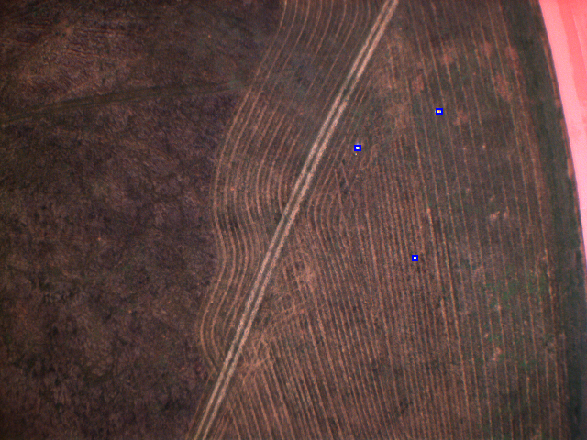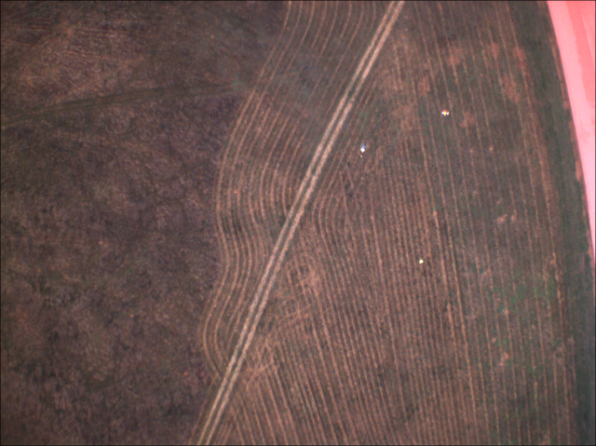

2 - Image detection of Joe

## Results

One of our major results to date is Joe detection. Above is an image captured by the colour camera on our UAV, from a height of 120m. In the left image, the three “test Joes” can be seen as small white dots. The second image on the right (cropped and zoomed in) shows the output of our Joe detection, where the image analysis has successfully found the three Joes, outlined in blue boxes.

Further work on this will include a more robust and consistent detection. We have confirmed that the image analysis can run in realtime on our on-board computer.

Our APM has thoroughly demonstrated its ability to track a series of waypoints, in both calm and windy conditions. The above image shows the UAV following a four point box course around CMAC. Some fine tuning of the APM parameters still needs to occur to compensate for altitude correction.

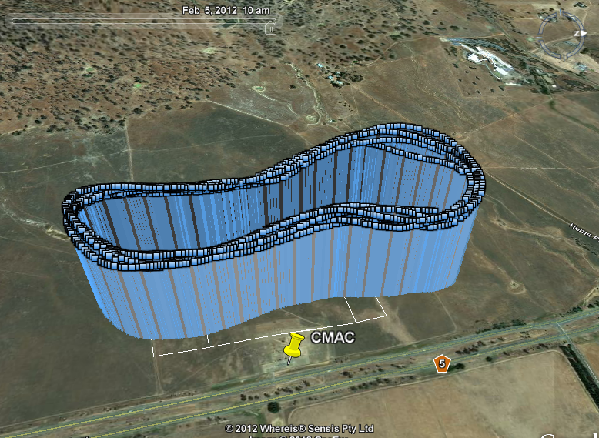

3 - Flight track over a 4 waypoint course at CMAC

We have run extensive tests of the sensor suite onboard the UAV in order to confirm their suitability and accuracy. This was achieved by using multiple sensors to measure the same parameter. This was done for airspeed (GPS vs pitot tube), altitude (GPS vs barometric pressure sensor) and compass heading (GPS vs magnetometer). An example of this is shown in Figure 4 below, where the variance in altitude sensors can be seen. Using this data, we were able to refine the algorithms used for measuring altitude.

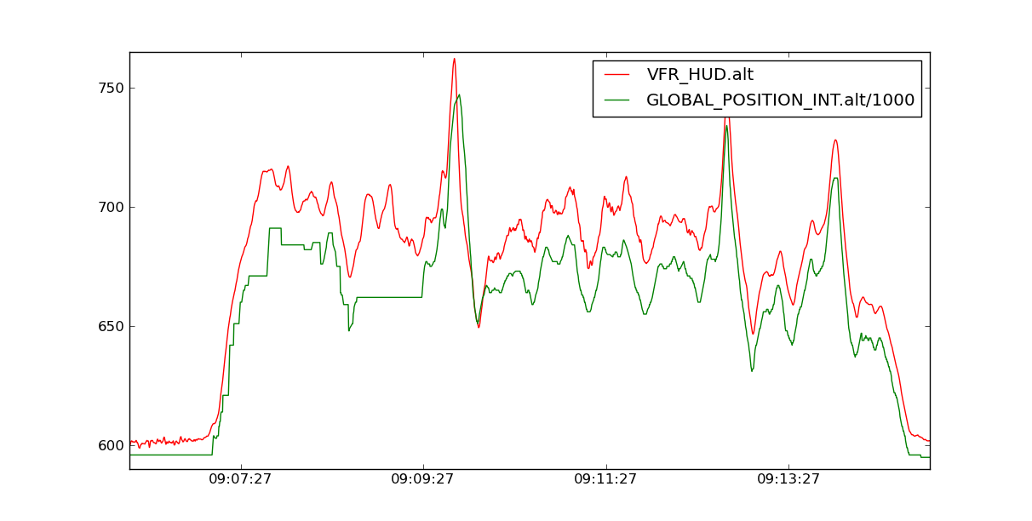

4 - Comparing the altitude of the UAV using barometric pressure (red) and GPS (green). The vertical scale is in metres (above sea level), horizontal scale in HH:MM:SS (time of day).

Additional successful tests include

* Ground based radio range testing over 8km range, both for the 5.8 GHz and 900 MHz radios
* Geofencing developed and tested with multiple aircraft.
* Digital video transmission over 8km range, during ground-based testing.

## Conclusions

By using a design approach based upon safety and reliability, our UAV is well on its way to being ready for the Outback Challenge.

At this point in time, most of our subsystems have been tested in isolation. This includes:

* Autopilot
* Radio links
* Ground Control
* Image detection
* Bottle drop

We are very pleased with our results so far, which indicate that we are well progressed to having a UAV system with a good chance of completing the Outback Challenge. Through the continued hard work of our team members we will be on track to completing an UAV well before the competition deadline.

The next challenge for us is to complete the failsafe hardware/software and integrate it into the overall UAV avionics. Further along we aim to integrate all the subsystems systems into the UAV and begin running long-range tests of a similar nature to the Outback Challenge.

We are looking forward to meeting the other UAV Outback Challenge teams in September and competing in the challenge!

Team Name: CanberraUAV

We declare that this report and the entry that it describes complies with the rules of the 2012 UAV Challenge, and that we enter with the intention of competing in the spirit of the challenge. Specifically we declare that our entry is compliant with the following topics and provide reference to within our Deliverable 2 document were our method of compliance is described:

|  |  |  |  |
| --- | --- | --- | --- |
| **Rules Reference** | **Topic** | **Compliance** | **Deliverable 2 Reference** |
| **Mandatory / Essential**  *(Note: Non-compliance in this section will result in a No-Go finding unless there are significant and/or extenuating circumstances. Please read the rules in detail with a view to safety and specific requirements.)* | | | |
| 5.1 | Aircraft Requirements and Limitations: All. | ✓ Compliant  □ Non-Compliant | Section 5 |
| 5.3.1, 5.3.2, 5.18, 8 | Radio Equipment Frequencies: ACMA Compliance and Licensing. | ✓ Compliant  □ Non-Compliant | Section 6.1 |
| 5.4 | UAV Controller Override: Compliance to override requirement or Safety Case provided. | ✓ Compliant  □ Non-Compliant  *□ Override*  *□ Safety Case* | Section 6.2 |
| 5.5 | In Flight Failures and Emergencies: All.  (Once activated it cannot be overridden – all modes.) | ✓ Compliant  □ Non-Compliant | Section 6.2 |
| 5.5.1 | Criteria for Flight Termination: All | ✓ Compliant  □ Non-Compliant | Section 6 |
| 5.5.2 | Loss of Data Link: All | ✓ Compliant  □ Non-Compliant | Section 6.3 |
| 5.5.3 | Engine Failure: Procedure provided in Deliverable 2. | ✓ Compliant  □ Non-Compliant | Section 6.4 |
| 5.5.4 | Loss of GPS: All and nomination of the implemented option for recovery. | ✓ Compliant  □ Non-Compliant  *□ Flight Termination*  *✓ Dead Reckon*  *□ Video* | Section 6.5 |
| 5.5.2, 5.5.4 | Loss of Data Link **and** Loss of GPS: All. | ✓ Compliant  □ Non-Compliant | Section 6.5 |
| 5.5.5 | Mission Boundary Crossing – GeoFence: All. | ✓ Compliant  □ Non-Compliant | Section 6.6 |
| 5.5.2, 5.5.5 | Loss of Data Link **and** Mission Boundary Crossing – GeoFence: All. | ✓ Compliant  □ Non-Compliant | Section 6.3 |
| 5.5.6 | “Lock Up” or Failure of Autopilot: All. | ✓ Compliant  □ Non-Compliant | Section 6.7 |
| 5.5.7 | “Lock Up” or Failure of GCS: All. | ✓ Compliant  □ Non-Compliant | Section 6.8 |
| 5.5.8 | “Lock Up” or Failure of Stability Augmentation System (SAS): All. | ✓ Compliant  □ Non-Compliant  □ Not Applicable | Section 6.10 |
| 5.6 | Flight Termination: All and nomination of the implemented option | ✓ Compliant  □ Non-Compliant  *✓ 5.6 Implemented*  *□ 5.6.1 Implemented*  *□ 5.6.2 Pyrotechnics* | Section 6.2 |
| 5.6.1 | Commercial off the shelf Flight Termination System used: manufacturer evidence provided | □ Compliant  □ Non-Compliant  ✓ Not Applicable | N/A – using custom developed system |
| 5.9 | Team Sponsors: All. | ✓ Compliant  □ Non-Compliant | Section 4 |
| 5.15 | Situational Awareness: Graphical display of waypoints and aircraft location. | ✓ Compliant  □ Non-Compliant | Section 5.7 |
| 6.2.1 | Statement of Originality and Accuracy: All. | ✓ Compliant  □ Non-Compliant | Section 2 |
| 6.2.2 | Compliance Statement: All. | ✓ Compliant  □ Non-Compliant | Compliance Statement |
| 6.3.1 | Requirements for Deliverable 3: Details of evidence to be provided. | ✓ Compliant  □ Non-Compliant | See “Additional Information” below |
| **Highly Desirable** | | | |
| 5.14 | Access to Video Stream from UAV | ✓ Compliant  □ Non-Compliant | Section 5.7 |
| 5.15 | Situational Awareness: NMEA 0183 Output. | ✓ Compliant  □ Non-Compliant | Section 5.7 |
| 5.16 | Li-Po Battery Management | ✓ Compliant  □ Non-Compliant | Section 6.9 |
| 6.2 | Deliverable 2: Max 17 pages. | ✓ Compliant  □ Non-Compliant | Yes |

Additional Information:

The Deliverable 3 proof of 5 hours flight will be in the following format(s):

* Google Earth kmz flight tracks
* MAVLink telemetry logs, including date and time identifiers (text and binary formats)
* Images from the onboard cameras
* Short videos of key parts of the flights
* A short report summarising the flight logs

These files will be made available of public websites. The link to these sites will be given closer to the D3 due date.

